**COMPUTER ENGINEERING DEPARTMENT**

**SUBMISSION REPORT**

**SUB: System Programming & Compiler Construction**

**COURSE: T.E. Year: 2020-2021 Semester: VI**

**DEPT: Computer Engineering**

**SUBJECT CODE: CSC602 SUBMISSION DATE: 19/05/2021**

==========================================================================================

|  |  |
| --- | --- |
| **Name: Amey Thakur** | **Roll No.: 50** |
| **Class: TE Comps B** | **ID: TU3F1819127** |

**INDEX**

|  |  |  |
| --- | --- | --- |
| **Sr.No.** | **Particulars** | **Submitted/Not Submitted or Enter Marks received** |
| **Experiments** | | |
| **1** | EXP 1: Develop a program to implement a lexical analyzer using Finite Automata. | 9/10 |
| **2** | EXP 2: implement Lexical Analyzer for given language using Lex tool. | 7/10 |
| **3** | EXP 3: To implement the program to remove left recursion from grammar and find first and follow the given grammar. | 8/10 |
| **4** | EXP 4: To implement any parsing technique. | 8/10 |
| **5** | EXP 5: To implement any code optimization techniques. | 8/10 |
| **6** | EXP 6: To generate target code. | 8/10 |
| **7** | EXP 7: To design and implement the first pass of a two-pass assembler for IBM 360/370 Processor. | 8/10 |
| **8** | EXP 8: To design and implement the second pass of a two-pass assembler for IBM 360/370 Processor. | 7/10 |
| **9** | EXP 9: To Design and Implement a two-pass Macro Processor. | 8/10 |
| **Assignments** | | |
| **13** | Assignment No. 1 | 10/10 |
| **14** | Assignment No. 2 | 10/10 |
| **15** | Assignment No. 3 | 10/10 |
| **Quizzes** | | |
| **16** | SPCC Quiz 1 | 10/10 |
| **17** | SPCC Quiz 2 | 10/10 |
| **18** | SPCC Quiz 3 | 10/10 |
| **19** | SPCC Quiz 4 | 10/10 |
| **20** | SPCC Quiz 5 | 10/10 |
| **21** | SPCC Quiz 6 | 10/10 |
| **IAT** | | |
| **22** | IAT-1 | 18/20 |
| **23** | IAT-2 | Submitted |
| **Exit Survey** | | |
| **24** | Course Exit Survey | Submitted |
| **25** | Laboratory Exit Survey | Submitted |

**Signature:**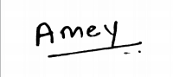

**Experiments**

**SPCC Experiment 1**

**Marks: (9/10)**

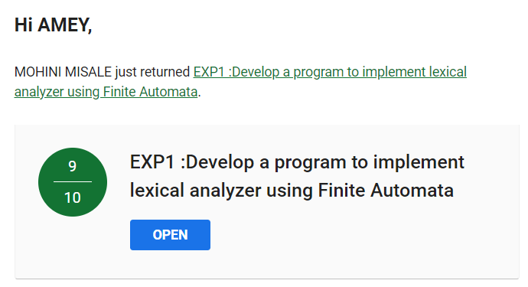

**SPCC Experiment 2**

**Marks: (7/10)**

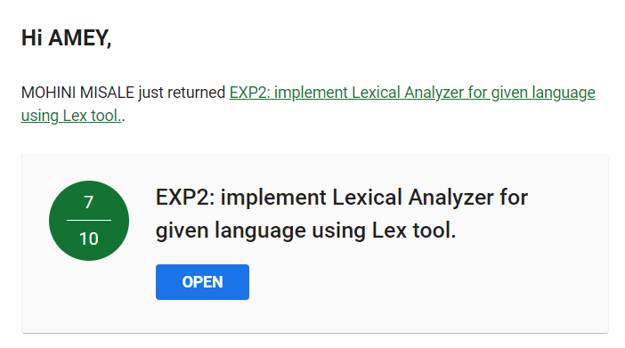

**SPCC Experiment 3**

**Marks: (8/10)**

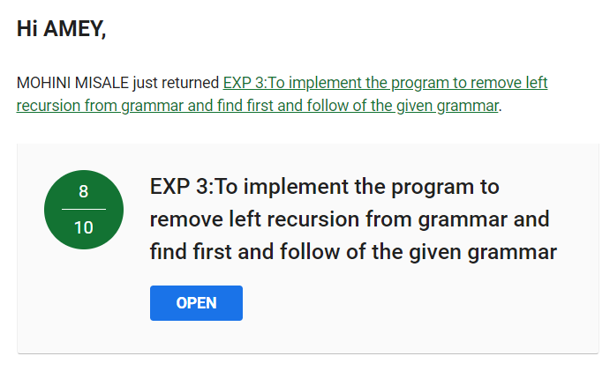

**SPCC Experiment 4**

**Marks: (8/10)**

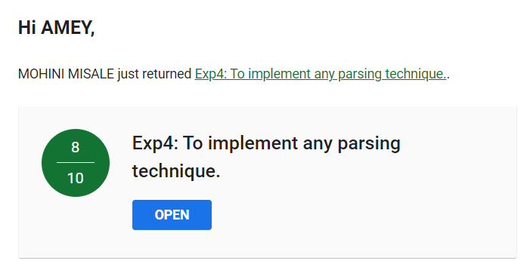

**SPCC Experiment 5**

**Marks: (8/10)**

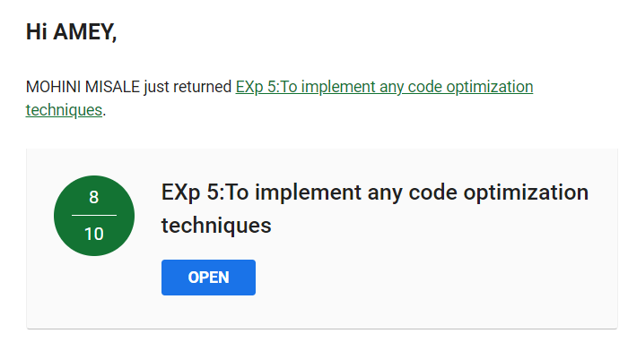

**SPCC Experiment 6**

**Marks: (8/10)**

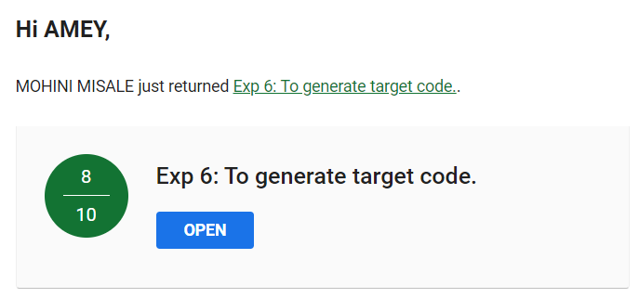

**SPCC Experiment 7**

**Marks: (8/10)**

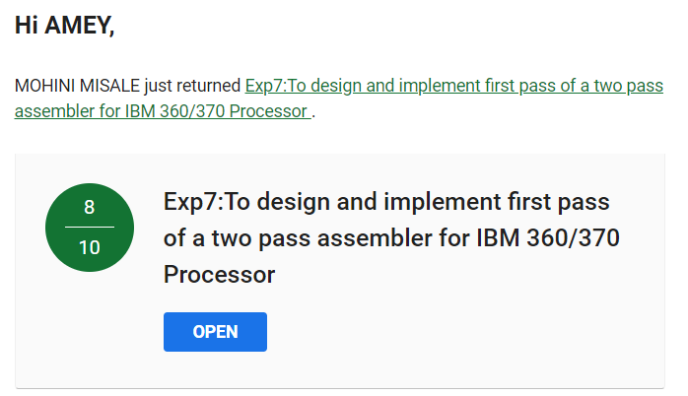

**SPCC Experiment 8**

**Marks: (7/10)**

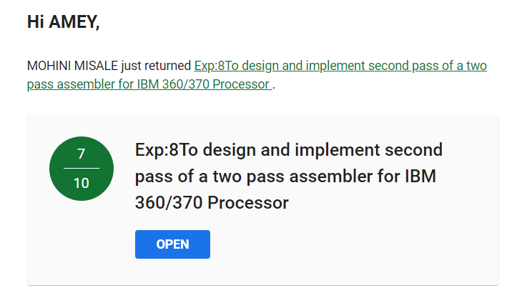

**SPCC Experiment 9**

**Marks: (8/10)**

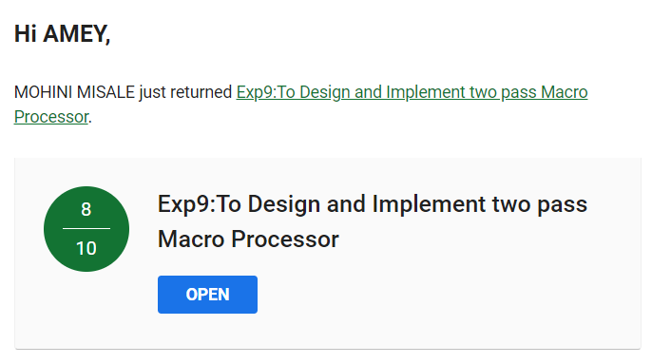

**Assignments**

**SPCC Assignment 1**

**Marks: (10/10)**

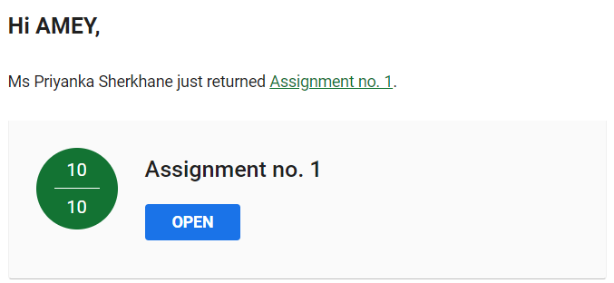

**SPCC Assignment 2**

**Marks: (10/10)**

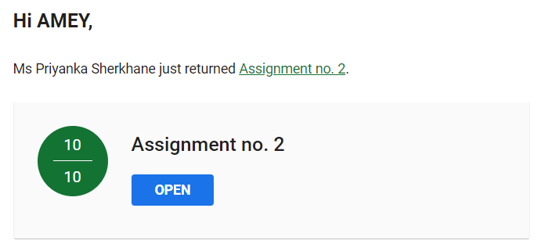

**SPCC Assignment 3**

**Marks: (10/10)**

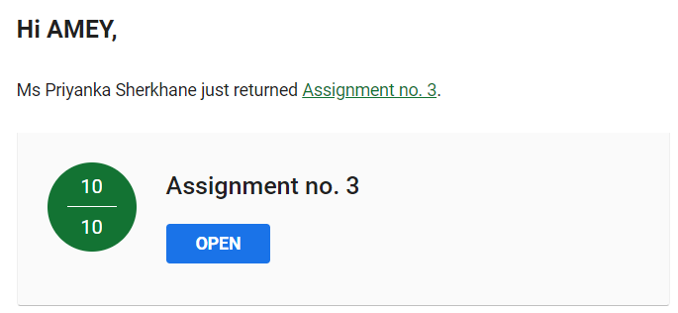

**Quizzes**

**SPCC Quiz 1**

**Marks: (10/10)**

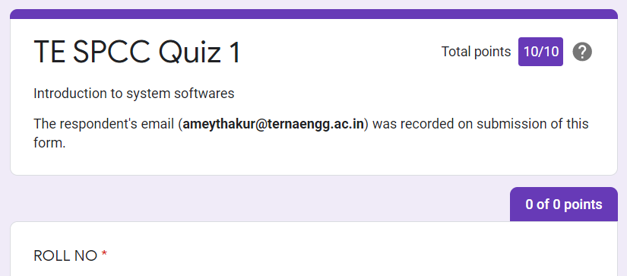

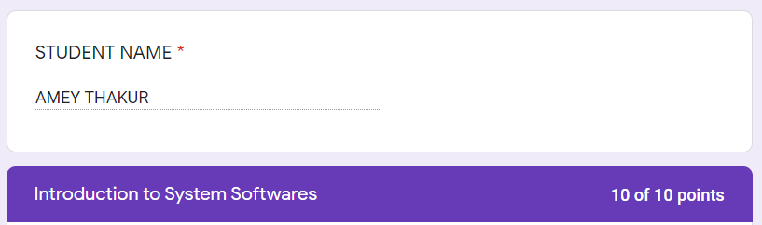

**SPCC Quiz 2**

**Marks: (10/10)**

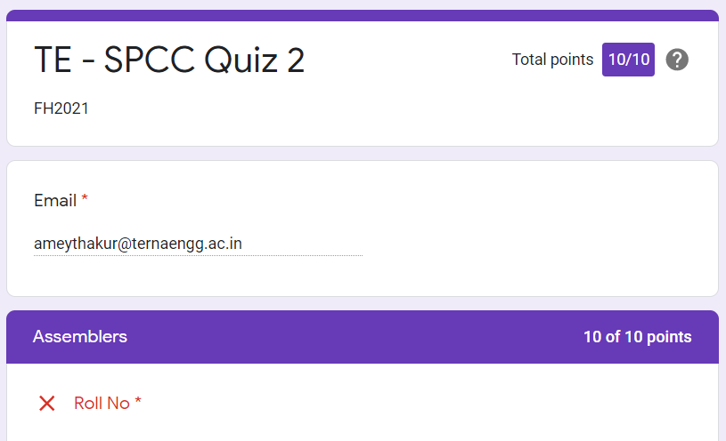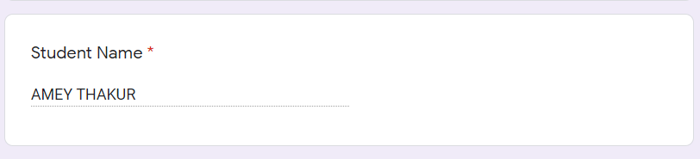

**SPCC Quiz 3**

**Marks: (10/10)**

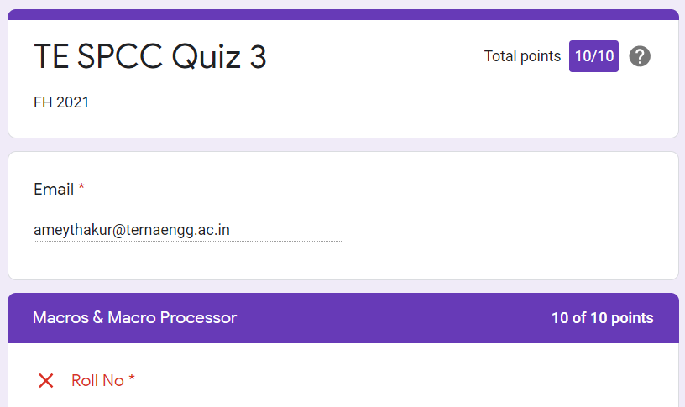

**SPCC Quiz 4**

**Marks: (10/10)**

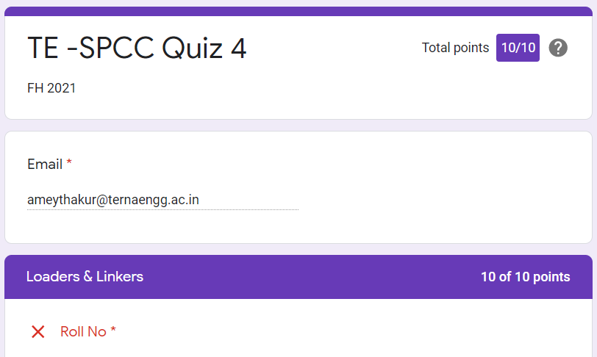

**SPCC Quiz 5**

**Marks: (10/10)**

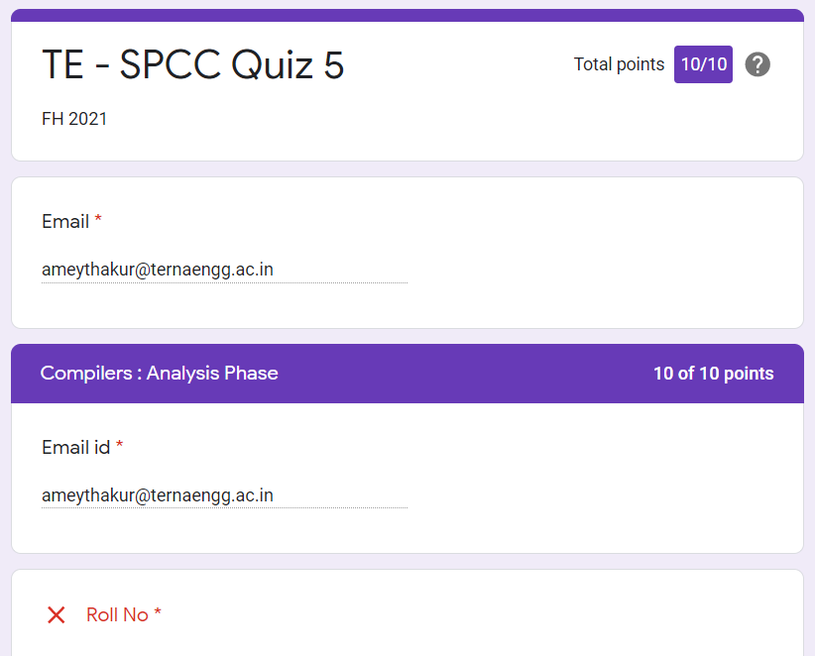

**SPCC Quiz 6**

**Marks: (10/10)**

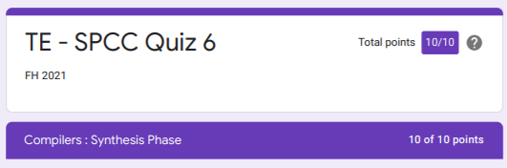

**IAT**

**SPCC IAT 1**

**Marks: (18/20)**

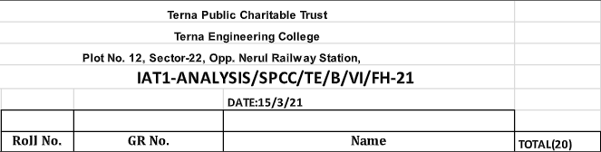

**IAT 1 Descriptive Answer Sheet**

**(First page attached)**

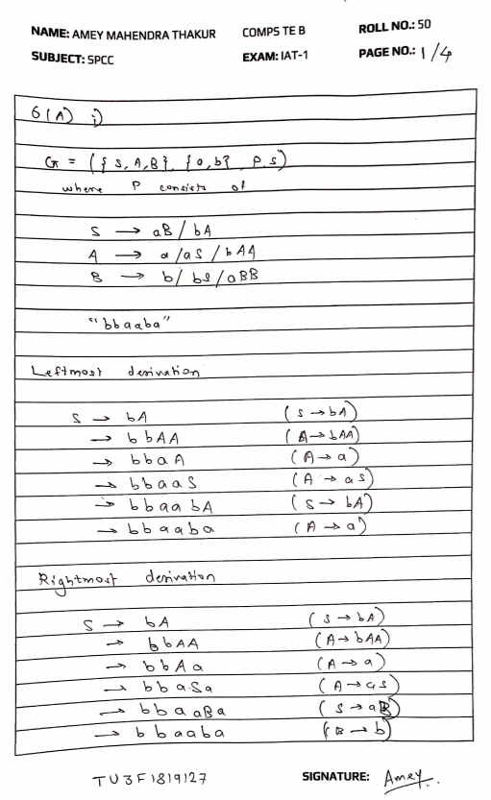

**SPCC IAT 2**

**Marks: Not Received**

**IAT 2 Descriptive Answer Sheet**

**(First page attached)**

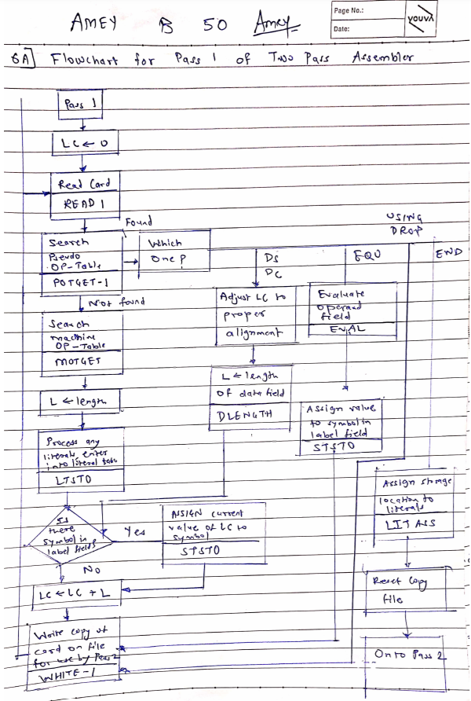

**Exit Survey**

**SPCC Course Exit survey**

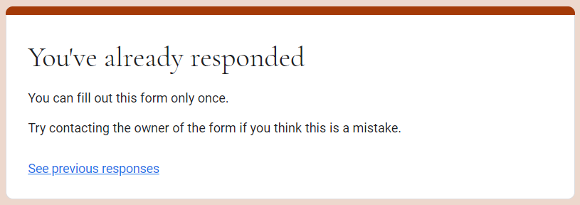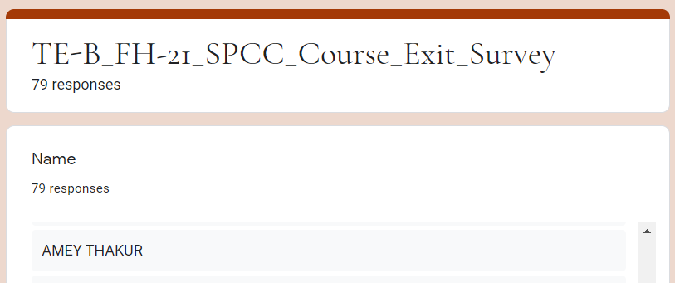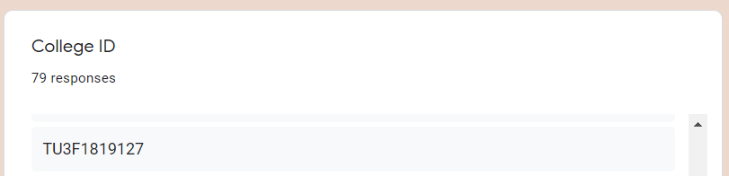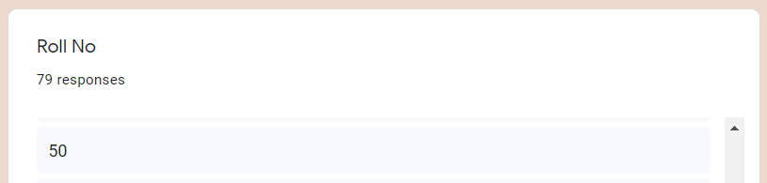

**SPCC Laboratory Exit Survey**

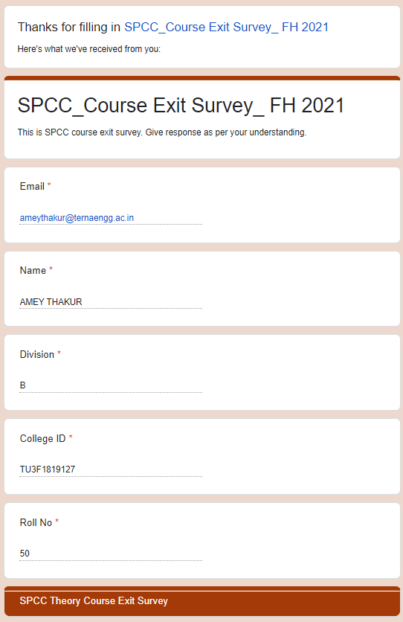

**Google Classroom Submission Report**

